Statement of Work

for

Street Map

(Plug-in for VideoXpert Ops Center)

|  |  |
| --- | --- |
| **Version:** | 1.1 |



**QuEST Global Corporation**

|  |  |
| --- | --- |
| **Copyright Notification:** | This document is the property of QuEST Global Engineering Services Pvt. Ltd. No part of this document may be reproduced except as authorized by written permission from QuEST Global Engineering Services Pvt. Ltd. The copyright and the foregoing restriction extend to reproduction in all media. |
| **Format ID:** | QuEST/wFM/139 V3.0 |

**Revision History**

|  |  |  |  |  |
| --- | --- | --- | --- | --- |
| Version | Date | Description | Prepared/ Amended By | Approved By |
| **0.9** | 24-June-2016 | Initial Draft | Shanadas C, Augustine T.J | Vijo Varghese |
| **1.0** | 07-July-2016 | Updated | Shanadas C, Augustine T.J | Vijo Varghese, Jishin Salim |
| **1.1** | 11-July-2016 | Updated | Shanadas C, Augustine T.J | Vijo Varghese, Jishin Salim |

This document is governed by the Development Agreement between Pelco, Inc and SFO Technologies Corporation effective February 14, 2014 and is fully incorporated therein. In the event of a conflict between the terms of the Agreement and the provisions of this document, the main body of the Agreement shall govern and control with respect to the transactions contemplated by this document. All capitalized terms used in this document and not otherwise defined will have the same meaning as in the Agreement

**CONTENTS**

1. Executive Summary 7

2. High Level Understanding of Project Scope 7

3. Company Information 7

3.1. Name of the Bidder 7

3.2. Addresses of Offices/Facilities 7

3.3. Points of Contact 8

4. Proposal 8

4.1. System Overview 8

4.2. Acronyms 9

4.3. References 9

4.4. Scope of Work 9

4.4.1. Stated Requirements 10

4.4.2. Wireframes 11

4.5. Technical Solution 24

4.5.1. Internationalisation Support 26

4.6. Execution Strategy 26

4.6.1. Team Structure 26

4.6.2. Schedule and Milestone 27

4.6.3. Support from Customer 29

4.6.4. Reporting and Communication 29

4.6.5. Assumptions & Limitations 30

4.6.6. Risks 30

4.6.7. Out of Scope 31

4.7. Commercials 31

4.7.1. Development Charges 31

4.7.2. Billing and Payment 31

4.8. Terms & Conditions 32

4.8.1. Validity of the Proposal 32

4.8.2. Handling Schedule, Cost & Effort Escalation 32

4.8.3. Duties and Taxes 33

4.8.4. Acceptance 33

4.8.5. Warranty 33

4.8.6. Arbitration 34

4.8.7. Handling of Exceptional Circumstances 34

4.9. Appendix 35

4.9.1. Alternatives- Maps 35

Figure 1 System Overview 8

Figure 2 Main UI 11

Figure 3 Camera Layer 12

Figure 4 Camera Layer - Tooltip 13

Figure 5 Camera Layer - Event notification 14

Figure 6 Camera Layer - Tag filtering 14

Figure 7 Cruiser Layer 15

Figure 8 City Traffic 16

Figure 9 Zoom and Pan 17

Figure 10 List of location 18

Figure 11 Add new location - Context menu 18

Figure 12 Add new location 19

Figure 13 Map in Edit mode 20

Figure 14 Add new camera 20

Figure 15 Import cameras from CSV 21

Figure 16 Edit mode - Save changes 22

Figure 17 Architecture Diagram 25

Figure 18 Team Structure 27

Figure 19 Project Schedule 28

1. Executive Summary

This document is a Statement of Work in response to the enquiry from Pelco for developing a VideoXpert Ops Center plug-in for local police agencies in the United States. This document describes specific requirements addressed in this project, proposed technical solution and the development approach. The new plug-in brings in extended facilities and features to Pelco’s video management system by integrating cameras, events and live feeds with police call dispatch systems and Google maps. The new plug-in is tentatively named as “**Street Map**”.

1. High Level Understanding of Project Scope

The scope of this project is to design and develop Street Map plug-in for VideoXpert Ops Center. The plug-in shall be primarily used by local police agency in the United States. It shall integrate live feeds and events from cameras with police call dispatch systems and maps. The plug-in user interface visualizes police cruisers and cameras over Google maps in real time. This document covers the development plan, schedule, milestones and technical solution for completing the development of the system as per the proposed technical solutions detailed under Sec 4.5. below in this document.

1. Proposal
   1. System Overview

The proposed solution is a proactive support system for local police agency. The scope of the project is to develop a content plug-in for VideoXpert Ops Center. It shall provide an integrated view to the agency for monitoring the city with the help of cameras, streams and cruiser locations on Google maps.

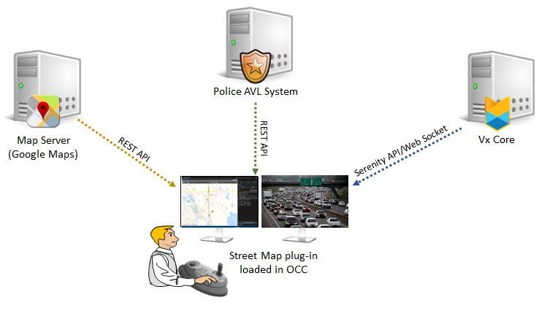

Figure System Overview

The video management system provides live streams and events from various IP cameras that are placed in different parts of the city. The Street Map plug-in integrates camera streams with data from police cruise transit and call dispatch systems. Cameras and cruisers are displayed over Google map with various status indicators. The plug-in provides a seamless experience in monitoring the city with the aid of live video and detailed information about the nearby cruisers, which can attend a case. Traffic information in the city can also be viewed, which provides an insight to the operator on how best or who best could attend a call.

* 1. Acronyms

|  |  |
| --- | --- |
| Term | Description |
| VMS | Video Management System |
| OCC | Ops Center Client |
| GUI | Graphical User Interface |
| API | Application Programming Interface |
| IP | Internet Protocol |
| WPF | Windows Presentation Foundation |
| EF | Entity Framework |

* 1. References

|  |  |
| --- | --- |
| Document/Inputs | Description |
| Discussions | Technical and requirement analysis discussion between QuEST and Pelco |
| OCC_Plug-In_API_Version_1.4-CustomerFacing.pdf | Ops Center plug-in API document |
| Plug-in development experience | Learnings from the development and maintenance of Mapping plug-in |

* 1. Scope of Work

The scope of work includes,

* Design, development and testing of Street Map plug-in for VideoXpert Ops Center.
* Integration of Google Maps API with the plug-in to visualize the city being monitored.
* Integration of traffic information from Google Maps API to the map view of the plug-in.
* Integration of Police AVL System API with plug-in to provide information related to police cruisers, its locations and call status.
* Integration of camera streams and events from VideoXpert systems.
  + 1. Stated Requirements
* Design and develop a plug-in for VideoXpert Ops Center by integrating camera streams and events with Google maps and Police AVL System.
* Develop a user interface to display information regarding cameras, streams, events, police cruiser transit, call status and traffic in Google Maps.
* Plug-in should have provision to select and view various locations in the map. Locations can be added, edited and deleted from a list of locations. Locations can be added from the context menu button at an interested location in map.
* Plug-in should provide features to zoom and pan the Google maps.
* There should be provision to add IP cameras by right clicking on a location and selecting from a list of cameras presented.
* There should be provision to add multiple cameras by importing from CSV file. Imported camera details shall be mapped to Vx cameras based on IP addresses.
* There should be provisions to move, rotate and then save the camera location and angle dropped in the map.
* Events such as camera offline, onscreen and alarms generated from cameras should be represented using color changes in camera icons.
* Zooming action should happen in such a manner that both map and camera should be in synchronization.
* A double-click on IP camera in map should start the live streaming. Camera stream can also be viewed by dragging and dropping from the plug-in to another cell.
* Camera pinned on the map should show the tooltip which includes longitude and latitude details, camera details such as online/offline status, recording status, IP details and a snapshot of live feed from the camera.
* Plug-in should provide the live information about the current status of the police vehicles, whether it is moving or idle.
* Police cruisers on the map should have a tooltip with detailed information from AVL system related to the cruiser.
* Traffic information from Google maps should be available in the plug-in.
* The current status of the camera should be provided in the Street Map as onscreen, online and offline.
* It should be possible to show/hide the traffic information from Google maps.
* It should be possible to show/hide the police vehicles on the map.
* Status of the police vehicle should be represented using color codes.
* Develop a standalone installer which can install this plug-in in a system which has VideoXpert Ops Center
  + 1. Wireframes

This section contains wireframes representing the user interface of Street Map plug-in based on the high level requirements. The UI shall not be final and open to feedback and improvements.

* + - 1. Main UI

Once loaded, the plugin shall be displaying the Main UI as given below. The main UI has a tool bar on top and a map view. Map view contains the Google map of the selected city. Tool bar consists of list of locations that are already saved, toggle button for edit mode and icons to show/hide camera, vehicle and traffic on the map.

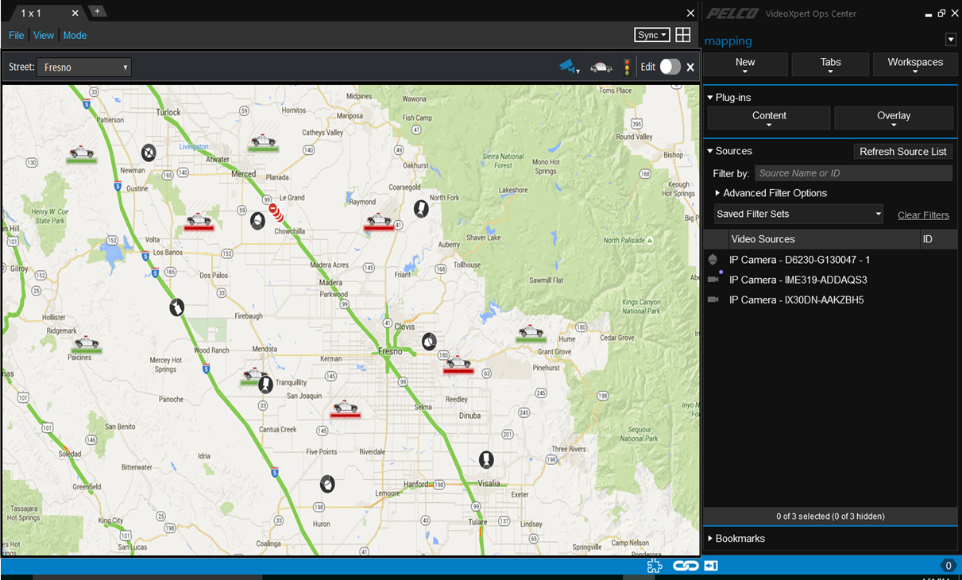

Figure Main UI

* + - 1. Camera Layer

The logical representation of cameras on the map based on physical locations can be enabled or disabled by toggling the camera icon in toolbar.

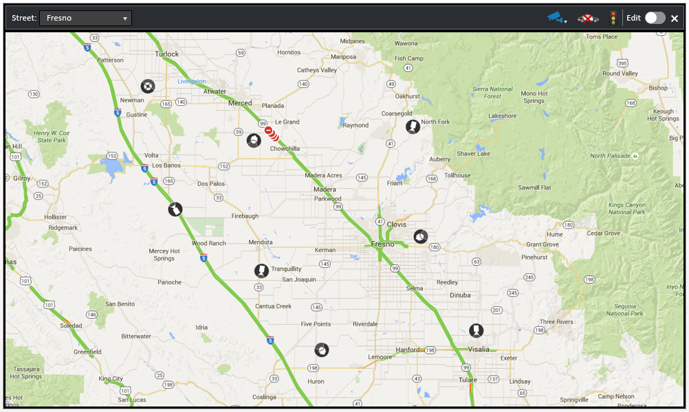

Figure Camera Layer

On mouse hover on a camera icon, a tooltip shall be displayed with camera details and snapshot of the live feed from the camera. User can launch the camera stream by double clicking the camera icon or dragging and dropping single or multiple selected cameras from Street Map plug-in to another cell. User can Ctrl+Mouse drag to select multiple cameras.

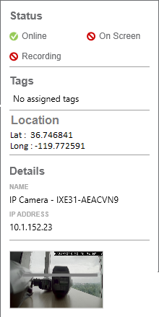

Figure Camera Layer - Tooltip

On the occurrence of an event, the UI will indicate the user by changing the existing camera icon to a notification icon.

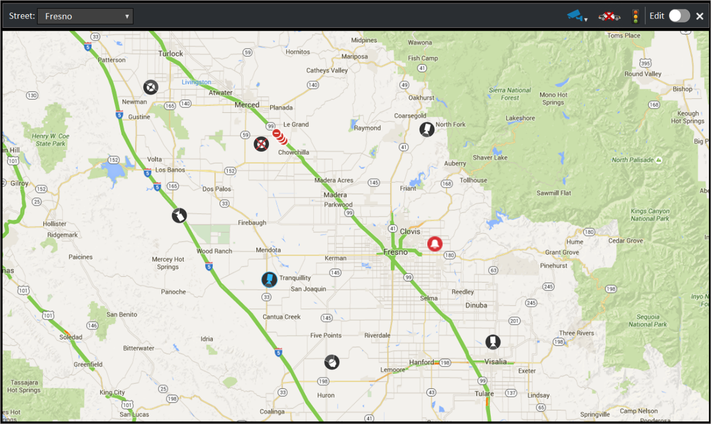

Figure Camera Layer - Event notification

Camera visibility can be filtered by selecting the tags. Only cameras with selected tags shall be shown in the map.

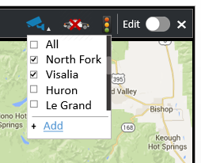

Figure Camera Layer - Tag filtering

* + - 1. Cruiser Layer

The real time location of police cruisers that are currently patrolling in the streets can be viewed on the map by enabling the cruiser layer. Police cruisers can have three states such as Available, In-Route, Busy at site. This status will be indicated with appropriate status icons.

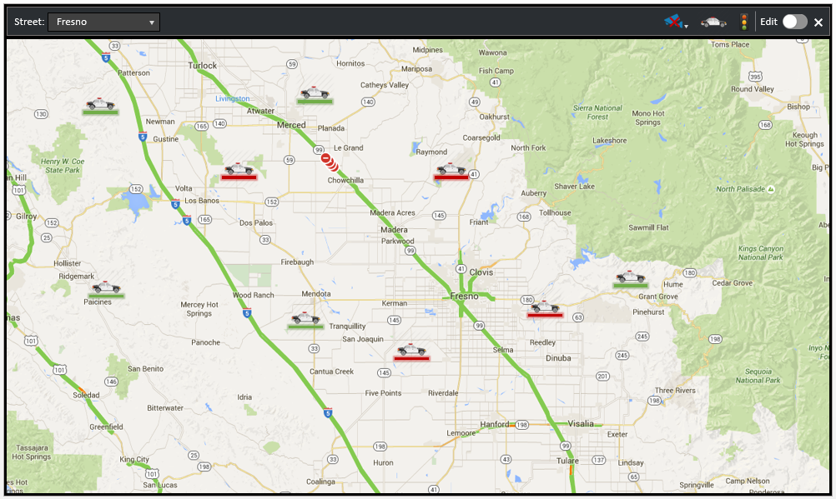

Figure Cruiser Layer

* + - 1. City Traffic

Current traffic information of the city from Google can be enabled or disabled by toggling the traffic icon in toolbar.

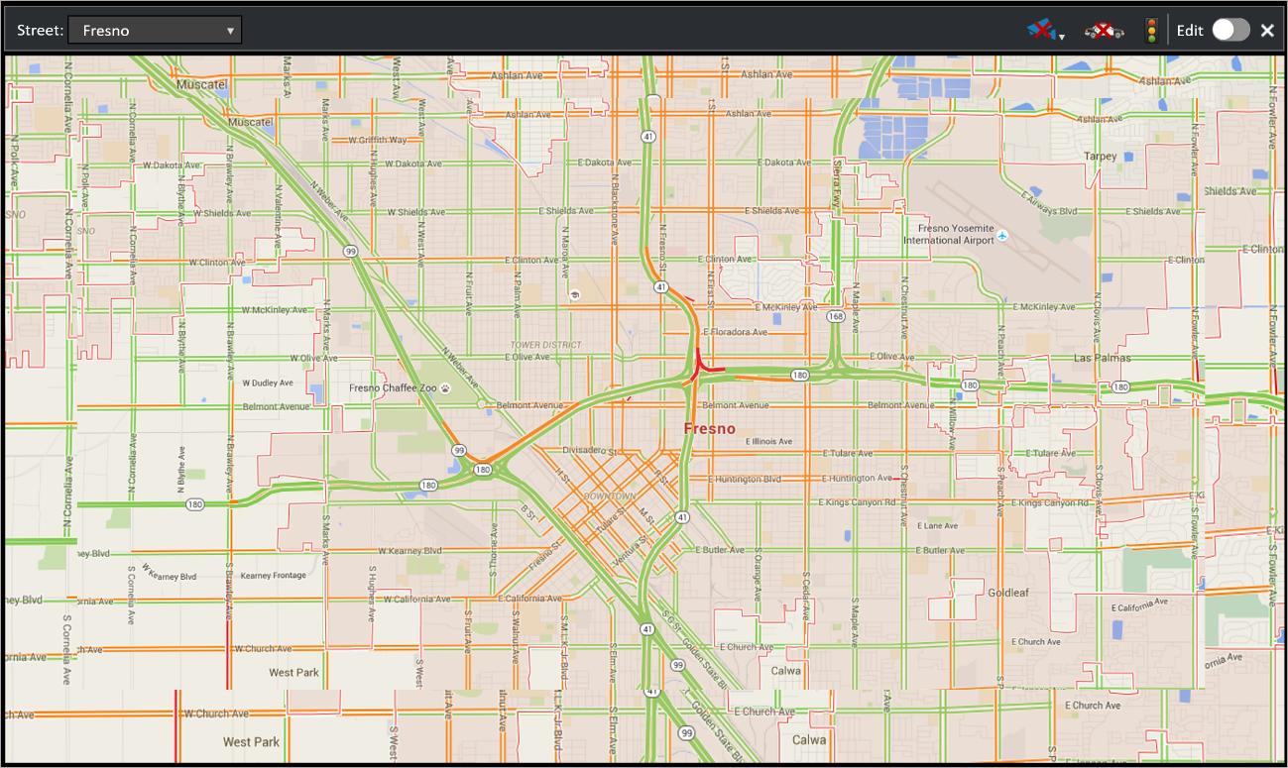

Figure City Traffic

* + - 1. Zoom and Pan

The map can be zoomed or panned to view detailed location analysis. Zooming of the map can be done by mouse scroll. Panning of the map is done by mouse dragging with right mouse button down.

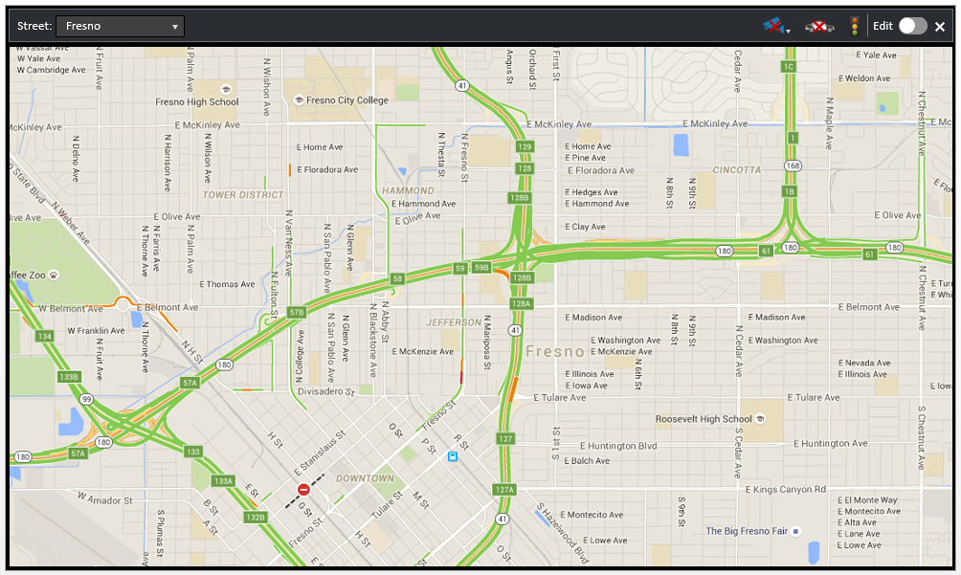

Figure Zoom and Pan

* + - 1. Locations

User can navigate to different saved locations by selecting from the list of locations available in the combo box. When user select a location from dropdown, the map should center that specified location.

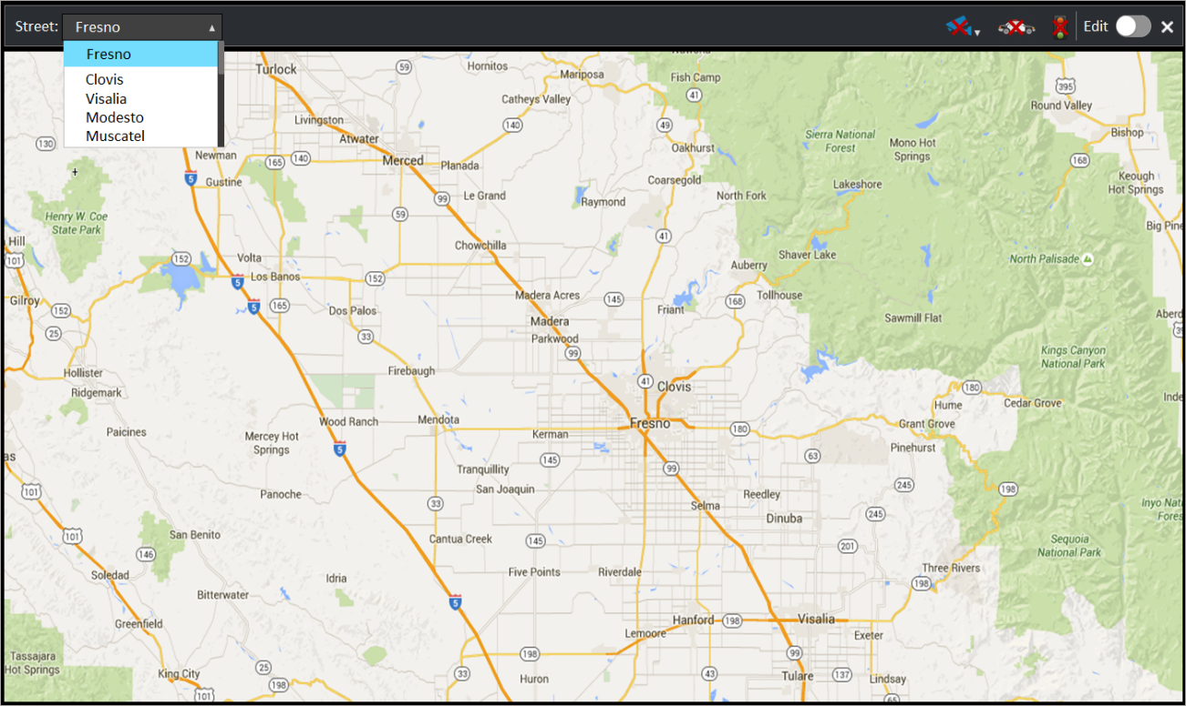

Figure List of location

A new location can be added from the map directly through context menu. User can right click on an interested location to bring out the context menu for adding it to the list of locations.

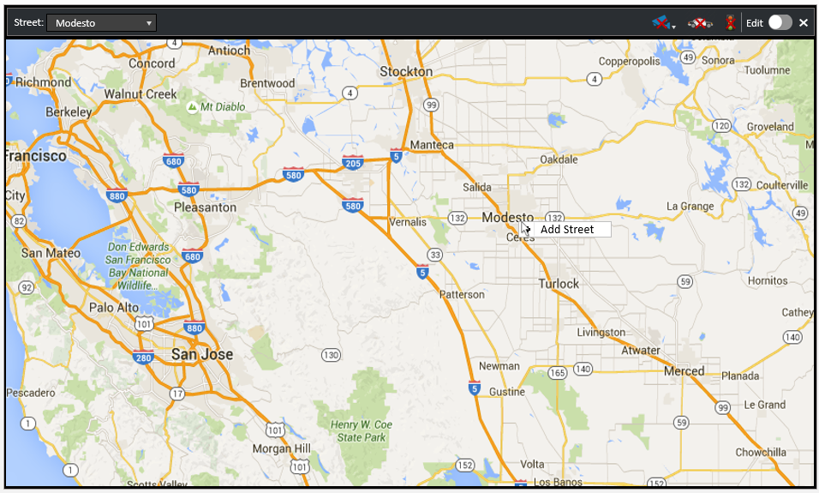

Figure Add new location - Context menu

On clicking the “Add Street” context menu a dialog box will appear to enter a name for the location. Latitude and longitude of the location shall be auto populated in read only text fields. Click on “Add” button to save the location.

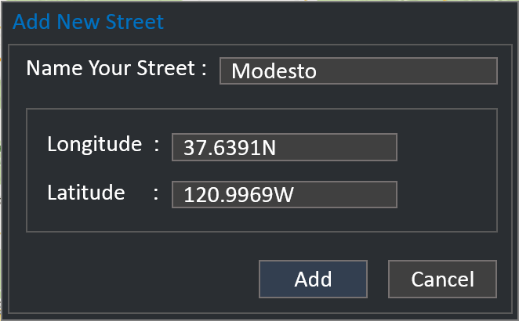

Figure Add new location

* + - 1. Edit Mode

The toggle button in the toolbar enables or disables the edit mode. Camera movement and rotation is made possible only if edit mode is enabled. On changing the state of edit mode from enable to disable, a dialog box will appear asking whether to save the changes or not. In the Edit mode, a click on the camera icon in the map will trigger it to selection mode which will be indicated by a change in icon. Then it is possible to move or rotate the camera by mouse movements.

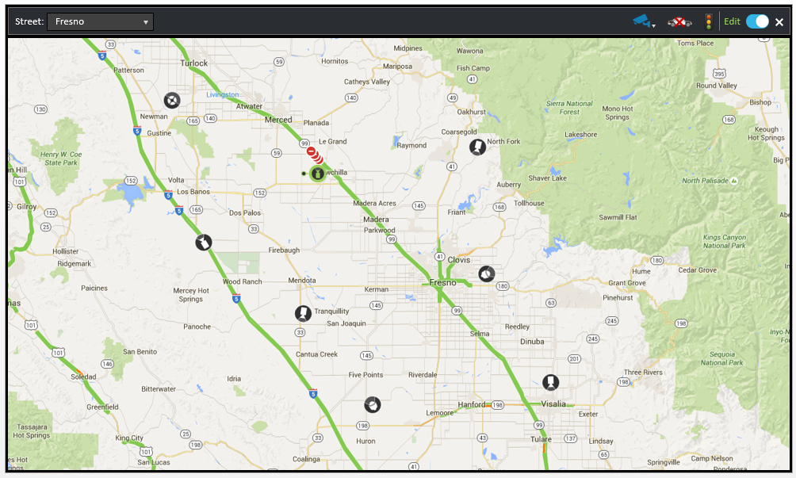

Figure Map in Edit mode

New cameras can be added to a location by right clicking on a location and selecting “Add Camera” from the context menu. On clicking the context menu, the user will be presented with a dialog for selecting the cameras present in the system.

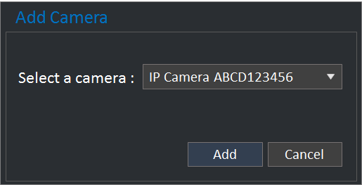

Figure Add new camera

Multiple cameras can be added simultaneously by importing from CSV file with IP address, latitude and longitude. Imported cameras shall be auto mapped to Vx cameras based on IP address. If needed user can override the mapping.

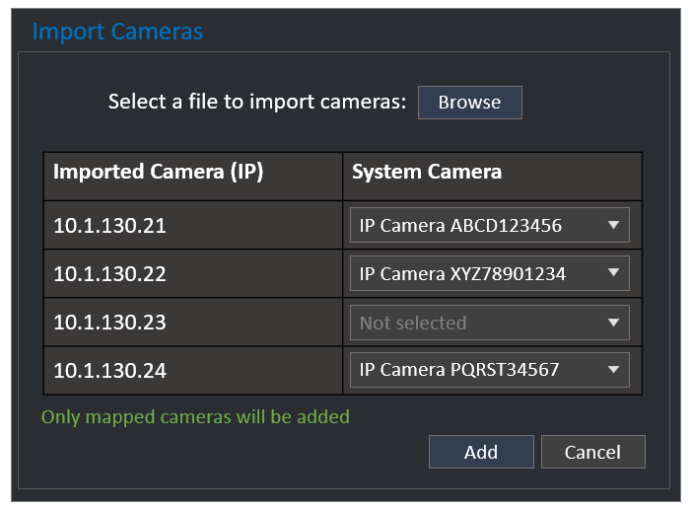

Figure Import cameras from CSV

Once leaving the edit a confirmation pops out asking whether to save or discard the changes done.

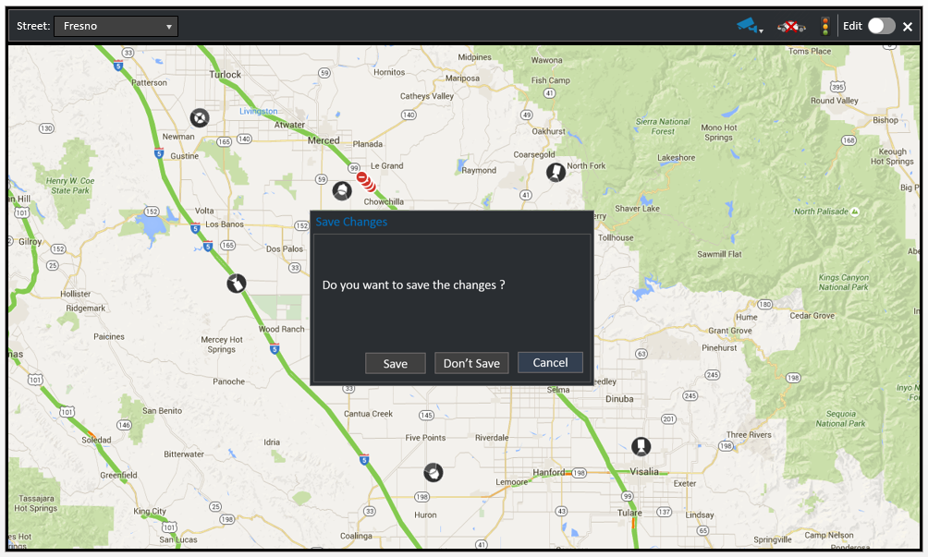

Figure Edit mode - Save changes

* + - 1. UI Legend

|  |  |
| --- | --- |
| **Icon** | **Indication** |
| **Camera Layer** | |
|  | Camera layer is visible in map |
|  | Camera layer is hidden in map |
|  | The map view contains cameras that are hidden due to a filter |
| **Cruiser Layer** | |
|  | Police cruisers are visible in map |
|  | Police cruisers are hidden in map |
| **Traffic Layer** | |
|  | Traffic information is visible in map |
|  | Traffic information is hidden in map |
| **Edit Mode** | |
|  | Currently in edit mode |
|  | Currently in view mode |

|  |  |
| --- | --- |
| **Icon** | **Indication** |
| **Normal** | |
|  | Fixed camera |
|  | PTZ camera |
|  | Panoramic camera |
| **Offline** | |
|  | Fixed camera offline |
|  | PTZ camera offline |
|  | Panoramic camera offline |
| **On Screen** | |
|  | Fixed camera currently playing in another cell of VideoXpert Ops Center |
|  | PTZ camera currently playing in another cell of VideoXpert Ops Center |
|  | Panoramic camera currently playing in another cell of VideoXpert Ops Center |
| **Edit mode selection** | |
|  | Fixed camera selected for movement or rotation |
|  | PTZ camera selected for movement or rotation |
|  | Panoramic camera selected for movement or rotation |
| **Alarm mode** | |
|  | Camera in alert state |
| **Cruiser States** | |
|  | Police cruiser in available state |
|  | Police cruiser in busy at site |
|  | Police cruiser is in route |

* 1. Technical Solution

QuEST has analysed the requirements identified during the discussions with Pelco. Based on the high level requirement analysis, QuEST is proposing following solution architecture. The proposed architecture is based on MVVM design pattern. Following diagram shows the high level architecture for the application being specified.

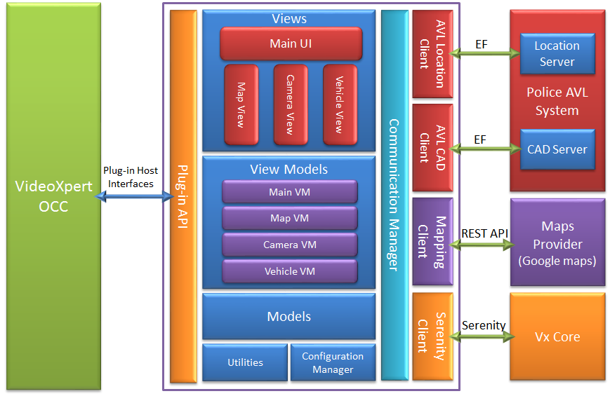

Figure Architecture Diagram

Street Map plug-in shall be developed as a content plug-in for VideoXpert Ops Center. Following are the high level modules identified. Exact modules in the system might vary after design phase.

* **Plug-in API**

Plug-in API layer represents the interfacing layer between the plug-in and host (VideoXpert Ops Center). This module consists of all interface implementations of plugin host interfaces.

* **Views**

Represents all UI components in the presentation layer. This module shall have following sub components.

* + Main UI
  + Map View
  + Camera View
  + Vehicle View
* **View Models**

This module consists of all view models that binds to each view in the UI layer. Following are the different view models in this module

* + Main VM
  + Map VM
  + Camera VM
  + Vehicle VM
* **Models**

This layer consists of various data models used in the application.

* **Communication Manager**

Communication manager is responsible for all the interfacing between external systems. It has components for communication with Police AVL System, Google Maps and VideoXpert Core.

* + AVL Location Client
  + AVL CAD Client
  + Mapping Client
  + Serenity Client

AVL Location client and CAD client shall use entity framework to connect to Police AVL system databases.

* **Utilities**

All utility functionalities such as application logging is handled by this module.

* **Configuration Manager**

Application configuration based on XML configurations are handled by this module. Police AVL system end points and related configurations are stored in XML file.

* + 1. Internationalisation Support

The plug-in shall support English language only. The application design shall have provision to expand to multiple languages in future.